|  |  |
| --- | --- |
| NGPF_LG.png | NGPF Activity BankChecking |

CALCULATE: Reconcile Your Checkbook

If you track your monthly checking account transactions manually, it’s important to compare your records with those of the bank’s to make sure you have an accurate knowledge of how much is in your account! In this activity, you will reconcile (or compare/match) a sample checkbook register and bank statement.

**Part I: Definitions**

Review the definitions below of the three things you need to reconcile your checkbook:

* **Checkbook Register** - Your Record of your transactions (page 2)
  + Note: You can access an editable version of this checkbook register [here](https://docs.google.com/spreadsheets/d/1UdB33a3NPdAKz5dGmVR-DSNzZQhqS4bXIogcp5wzdKU/edit#gid=0).
* **Bank Statement** - The Bank’s Record of your transactions (page 3)
* **Reconciliation Worksheet** - How you identify the missing transactions between the two (page 4).

**Part II: Reconcile Your Checkbook**

1. Match the Checkbook Register up with the Bank Statement.
   1. If a transaction is in **both** documents → check it off in the Checkbook Register in the checkmark column.
   2. If a transaction appears **only in the Checkbook Register** but NOT the Bank Statement → list that transaction in the Reconciliation Worksheet.
   3. If a transaction appears **only in the Bank Statement** but NOT the Checkbook Register → add it to your Checkbook Register.
2. How do you know when you are done? The total balance in your Checkbook Register matches the total balance in the Reconciliation Worksheet.

## Sample Completed Checkbook Register – Goes with Your Activity for Nov.

*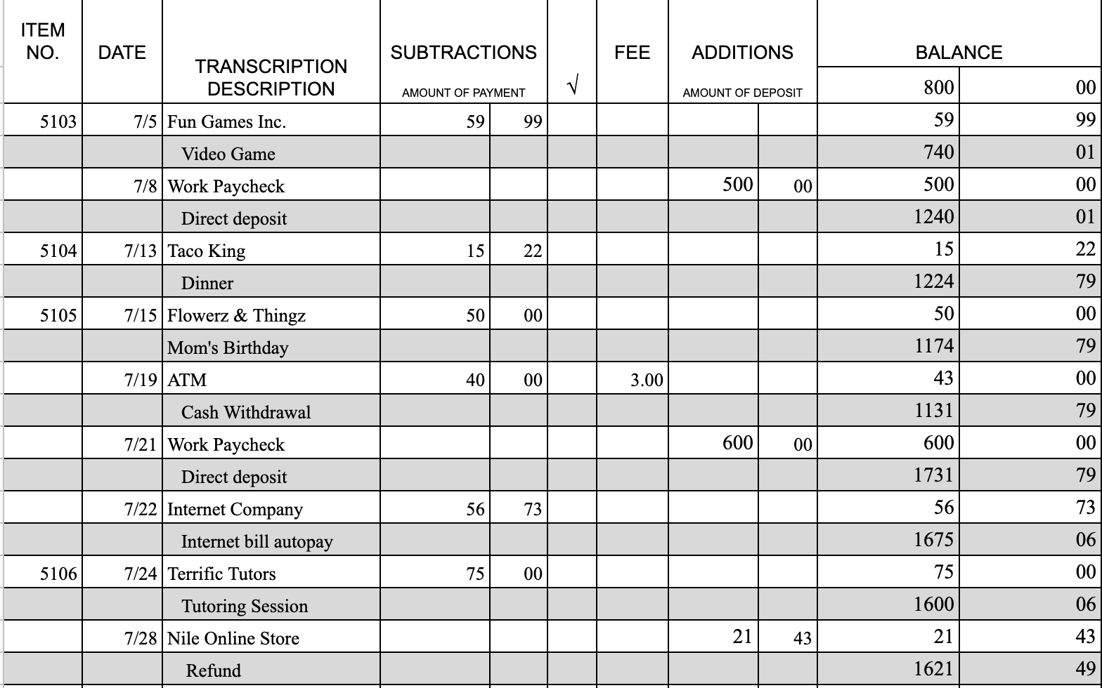*

00

800

03

97

489

310

03

489

11/5

11/21

11/22

11/24

11/28

11/19

11/15

11/13

11/8

11/5



Dep – Rummage Sale

DEP

*Sample Bank Account Statement*

|  |  |  |  |  |  |  |  |  |  |  |  |  |  |  |  |  |  |  |  |  |  |  |  |  |  |  |  |  |  |  |  |  |  |  |  |  |  |  |  |  |  |  |  |  |  |  |  |  |  |  |  |  |  |  |  |  |  |  |  |  |  |  |  |  |  |  |  |  |  |  |  |  |  |  |  |  |  |  |  |  |  |  |  |  |  |  |
| --- | --- | --- | --- | --- | --- | --- | --- | --- | --- | --- | --- | --- | --- | --- | --- | --- | --- | --- | --- | --- | --- | --- | --- | --- | --- | --- | --- | --- | --- | --- | --- | --- | --- | --- | --- | --- | --- | --- | --- | --- | --- | --- | --- | --- | --- | --- | --- | --- | --- | --- | --- | --- | --- | --- | --- | --- | --- | --- | --- | --- | --- | --- | --- | --- | --- | --- | --- | --- | --- | --- | --- | --- | --- | --- | --- | --- | --- | --- | --- | --- | --- | --- | --- | --- | --- | --- |
| **MEMBER STATEMENT**   |  |  | | --- | --- | | Your Credit Union  Anyplace USA | Page 1 of 1 | | Thomas B. Anderson  2063 Pleasant Road  Anywhere, USA 12345 | Statement Closing Date  Nov 30, 20XX |   **PREMIUM SHARE DRAFT ACCOUNT**   |  |  |  |  | | --- | --- | --- | --- | |  | Beginning Balance on June 30, 20XX | $ 348.00 |  | |  | Deposits and other additions | $ 1629.23 |  | |  | Checks paid and other subtractions | $ 306.95 |  |  |  |  |  |  |  | | --- | --- | --- | --- | --- | | *Trans*  *Date* | *Description* | *Debits* | *Credits* | *New Balance* |  |  |  |  |  |  | | --- | --- | --- | --- | --- | | 10/30 | Beginning balance |  |  | 348.20 | | 11/1 | ATM | 20.00 |  |  | | 11/1 | Verizon | 57.23 |  |  | | 11/1 | Deposit |  | 40.00 |  | | 11/1 | Deposit |  | $489.03 | 800.00 | | 11/5 | Check No. 5103 | 59.99 |  | 740.01 | | 11/8 | ACH: Payroll |  | 500.00 | 1240.01 | | 11/15 | Check No. 5105 | 50.00 |  | 1190.01 | | 11/19 | ATM: Withdrawal S51491 6 | 43.00 |  | 1147.01 | | 11/21 | ACH: Payroll |  | 600.00 | 1747.01 | | 11/22 | ATM: Withdrawal S98754 2 | 20.00 |  | 1727.01 | | 11/22 | ACH: Internet Company | 56.73 |  | 1670.28 | | 11/30 | Closing balance |  |  | 1670.28 | |

## Reconciliation Worksheet

|  |  |  |  |  |  |  |  |  |  |  |  |  |  |  |  |  |  |  |  |  |  |  |  |  |  |  |  |  |  |  |  |  |  |
| --- | --- | --- | --- | --- | --- | --- | --- | --- | --- | --- | --- | --- | --- | --- | --- | --- | --- | --- | --- | --- | --- | --- | --- | --- | --- | --- | --- | --- | --- | --- | --- | --- | --- |
| OUTSTANDING CHECKS/Debit Spending     |  |  | | --- | --- | | NUMBER | AMOUNT | |  |  | |  |  | |  |  | |  |  | |  |  | |  |  | |  |  | |  |  | |  |  | | **TOTAL** |  | | |  |  | | --- | --- | | ENDING BALANCE SHOWN  ON BANK STATEMENT | \_\_\_\_\_\_\_\_\_\_\_\_\_\_\_\_ | | (+) PLUS DEPOSITS  NOT SHOWN ON THIS STATEMENT | \_\_\_\_\_\_\_\_\_\_\_\_\_\_\_\_ | | SUB-TOTAL | \_\_\_\_\_\_\_\_\_\_\_\_\_\_\_\_ | | (-) LESS TOTAL OUTSTANDING Spending | \_\_\_\_\_\_\_\_\_\_\_\_\_\_\_\_ | | EQUALS ADJUSTED ENDING BALANCE | \_\_\_\_\_\_\_\_\_\_\_\_\_\_\_\_ |     **Adjusted ending balance shown above should agree with the balance shown in your Checkbook Register.**    Note: Be sure to deduct any charges, fees, or withdrawals shown on your statement (but not in your Checkbook Register) that may apply to your account. Also, be sure to add any dividends or any deposits shown on your statement (but not in your Checkbook Register) that apply to your account. |

1. What is the ACTUAL Balance in my Checking Account?

|  |
| --- |
|  |

1. Why is knowing this important?

|  |
| --- |
|  |